

UNDERGRADUATE PROJECT PROPOSAL

|  |  |
| --- | --- |
| **Project Title:** | **Class Reservation Management System** |
| **Surname:** | **Chen** |
| **First Name:** | **Hanly** |
| **Student Number:** | **201918020224** |
| **Supervisor Name:** | **Albert Xu** |
| **Module Code:** | **CHC 6096** |
| **Module Name:** | **Project** |
| **Date Submitted:** | **2022.11.11** |

**Table of Contents**

1 Introduction 3

1.1 Background 3

1.2 Aim 3

1.3 Objectives 3

1.4 Project Overview 4

1.4.1 Scope 4

1.4.2 Audience 5

2 Background Review 5

3 Methodology 6

3.1 Approach 6

3.2 Technology 8

3.3 Software/Project code version management plan 9

4 Project Management 9

4.1 Activities 9

4.2 Schedule 11

4.3 Data management plan 12

4.4 Project Deliverables 12

5 References 13

# Introduction

## Background

So far, human beings have completely entered the electronic information society, and more and more colleges and universities have adopted electronic information management to replace paper management. (Resmark, 2020) However, many online classroom appointment system pages are too complex, and the operation pages are not simple and efficient sufficient. Students are required to submit attendance records, and teachers are required to access student data, but the pages and management functions that are not convenient and concise can not assist them overcome obstacles. (Creatrix, 2022) In this background, a better classroom reservation management system aim will be designed and implemented based on Spring (spring Application Framwork) rationale and sprint model will be innovatively developed with the report function, dynamically display the relevant data of the system, and more concisely and efficiently manage the management information of university teachers and students entering and leaving the classroom, in order to assist teachers and students achieve success. (Programmerall, 2022) In the future, the vision will be released every Tuesday, including teacher management function and student appointment function.System, that is, a project group that often interacts or depends on each other to form a unified whole. (merriam,2022)

## Aim

Design and implement a better classroom reservation management system.

## Objectives

The objectives of the system are as follows:

1. completes the background review of the existing classroom reservation management system.

2. divides clear functions according to roles to facilitate data management.

3. has developed the teacher management function to display the user's usage in real time.

4. develops the function of students' classroom reservation, which can dynamically display relevant data of the system.

5. demonstrates the works to mixed audiences.

## Project Overview

### Scope

The audience of teachers will benefit. The administrator login function enables teachers to log in to the teacher appointment management system. The classroom information management function facilitates teachers to view and manage the details of the classroom. The appointment review function enables teachers to review students' appointment classroom applications. The appointment record query function enables teachers to view the appointment information reviewed in the past, The registered user function is convenient for teachers to register their own and students' accounts.

The student audience will benefit. The user login function enables students to log in to the teacher appointment management system. The classroom information query function facilitates students to view classroom details. The appointment record query function enables students to view their past appointment records. The classroom appointment function facilitates students to make classroom appointments. The personal information modification function enables students to correct incorrect personal information.

This system realizes the exchange and sharing of information in the classroom reservation system, and can carry out unified information management. It adopts Java, JSP, SSM and B/S architecture, and the database adopts MySQL developed by Oracle. (Jason, 2020) Control and manage the classroom reservation system information by integrating, analyzing and processing the information collected by the front end.

The purpose of the research is to optimize and improve the classroom reservation system, which is not simple and efficient sufficient to operate the pages, to assist teachers and students adopt dynamic information management and use reports to display data.

The significance of the research is to optimize the complex classroom appointment system on the market, make its pages simple and beautiful, simple and efficient operation pages, and use the dynamic report display method to save teachers and students time and energy to a large extent.(Creatrix, 2022)

### Audience

The project includes two audiences, teachers (administrators) and students (users);

# Background Review

Summary of existing approaches

According to the research, the teacher appointment system on the market usually uses waterfall model to cooperate with others and export the results to multiple formats for storage, in order to improve the quality and efficiency of teacher appointment system project development. (Ralph, 2021) But this makes the development process irreversible, otherwise the cost is too high, and the waterfall model makes it difficult to comply with all user requires, resulting in complex data and difficult user operations.（Bagyatech,2020）

At the same time, the teacher appointment system on the market can arrange students' schedules. (skedda, 2022) But these system pages are too complex, and the operation pages are not simple and efficient sufficient. Fortunately, the classroom reservation management system designed in this paper will develop a report function, which can dynamically display the relevant data of the system, and be original on the developed functional methods. Optimize the classroom reservation system on the market, make its pages simple and beautiful, simple and efficient operation pages, facilitate younger students and busy teachers, and greatly improve the competitiveness of the system.

# Methodology

## Approach

The software development model will adopt the agile model to promote the rapid completion of the project, generate well written compact programs through pair programming, make the development requirements of the project clearer, and obtain the idea of updating software products after each iteration by frequently delivering incremental versions of software to customer representatives every few weeks. (Michael, 2022) It solves the problem that the development process of waterfall model in the market has little or no change and users rarely participate in the development work.(Barry,2016) In addition, the project will be developed in the MVC(Model View Controller) as demonstraten below:

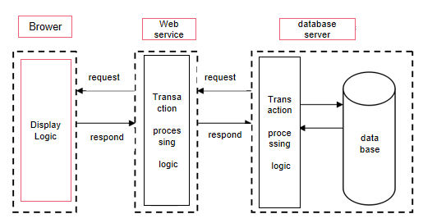

Figure1. MVC Frame Structure of the Third Floor

The demand collection method is to use Bing and the website of Chengdu University of Technology Library to search relevant documents for innovative development.

The system test principally adopts the black box test method. In this black box test, it is not necessary to understand the specific work flow inside the system, but from the user's point of view, to test whether each functional module of the system works according to the user's requirements by writing a good test case.

The evaluation process of the system is probably to test whether the user can complete the login. There are users with multiple roles in the system. Users in each role have their own permissions. Each user should choose their own role type when logging in. This module requires to test whether the system login enters the corresponding page according to the corresponding role. On the other hand, it is used to submit information viewing requests, test whether the information can be completely read from the database and displayed on the corresponding interface.

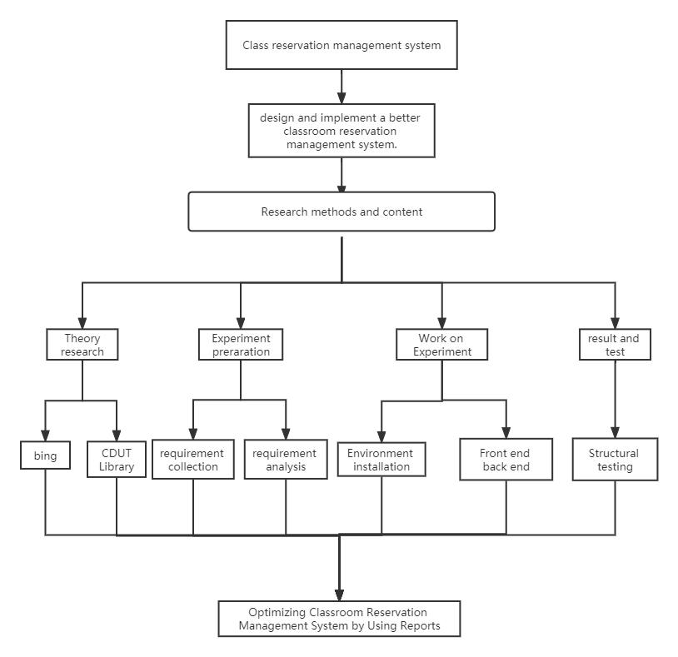

Figure2. Technical Roadmap

## Technology

In order to ensure the accuracy of the experiment, all experiments in this paper use the same platform, using dual video cards, and the memory size reaches 512G. The specific configuration is demonstrated in Table 1 below:

|  |  |
| --- | --- |
| Operating system | Windows |
| Development tool | Eclipse |
| Development technology: | Java |
| Database: | MySQL |
| Processor | Core i5 generation 4 series CPU main frequency, 2.7GHz dynamic, acceleration frequency: above 3.6GHz |
| Memory | 8G (or above) |
| Hard disk | 512G solid state disk (or above 512G) |

Table 1 Configuration of Experimental Platform

## Software/Project code version management plan

This project will use Baidu Cloud Disk as the platform for managing project code. With the features of easy, clear and timely browsing of Baidu Cloud Disk files, the project code completed every week will be timely uploaded to the corresponding folder to manage different versions of the project.

# Project Management

## Activities

The activities of the objectives are as follows:

1. completes the background review of the existing classroom reservation management system.(Deliverables: survey website and results, demand analysis conclusions, analysis of existing models)

1.1 System search for similar software (deadline: 2022.11.7)

1.2 Create Feature Comparison Table (deadline: 2022.11.9)

1.3 Complete literature search (deadline: 2022.11.11)

1.4 Literature review (deadline: 2022.11.13)

1. 1.5 Conduct user survey (deadline: 2022.11.15)divides clear functions according to roles to facilitate data management.(Deliverables: role function results, database table, ER diagram, function structure diagram)

2.1 Division of roles(deadline: 2022.11.22)

2.2 Functional division of the first role(deadline: 2022.11.27)

2.3 Functional division of the second role(deadline: 2022.12.2)

2.4 Feasibility analysis of divided functions(deadline: 2022.12.7)

2.5 Organize role function (deadline: 2022.12.12)

1. has developed the teacher management function to display the user's usage in real time.(Deliverables: background login code, management function code)

3.1 Design and develop administrator login function (deadline: 2022.12.17)

3.2 Design and develop classroom information management function (deadline: 2022.12.25)

3.3 Design and develop appointment audit function (deadline: 2022.12.31)

3.4 Design and develop appointment audit function (deadline: 2023.1.7)

3.5 Design and develop registered user functions (deadline: 2023.1.15)

1. develops the function of students' classroom reservation, which can dynamically display relevant data of the system.(Deliverables: homepage login code, reservation function code)

4.1 Design and develop user login function

4.1 Design and develop user login function (deadline: 2023.3.7)

4.2 Design and develop classroom information query function (deadline: 2023.3.15)

4.3 Design and develop reservation record query function (deadline: 2023.3.30)

4.4 Design and develop the function of reserved classroom (deadline: 2023.4.15)

4.5 Design and develop personal information modification function (deadline: 2023.4.30)

5. demonstrates the works to mixed audiences.

5.1 Materials and processes to be displayed (deadline: 2023.5.17)

5.2 Presentation process to mixed audiences (deadline: 2023.6.4)

## Schedule

The schedule is usually arranged for theoretical analysis within two weeks, experimental preparation within three weeks, and programming experiments within the remaining week. In the following semester, it will take five weeks to complete the programming experiment, another two weeks to test, and the subsequent feedback and demonstration time. The previous deliverables will be uploaded on the Tuesday of each week after the project starts, in order to approach the objectives. The deadline will be the eighth week of the second semester, as shown in the Gantt chart below:

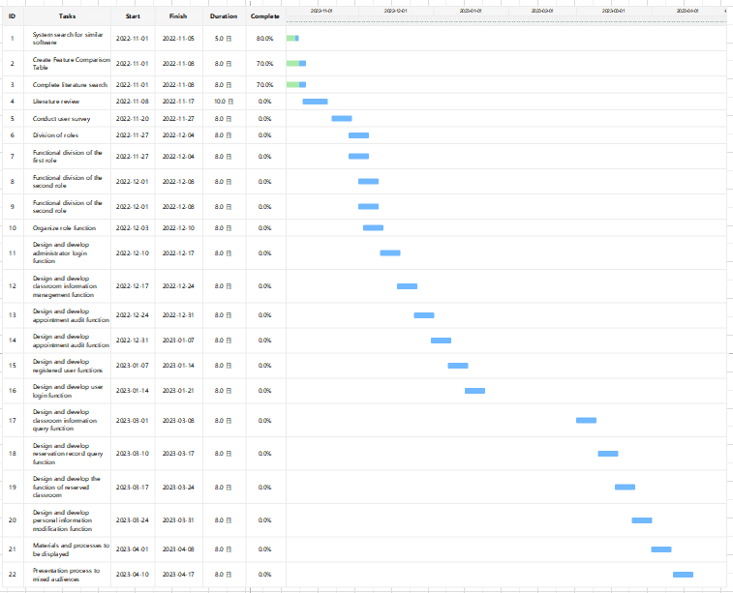

Figure3. Schedule Gantt Chart

## Data management plan

In the process of the project, every time the task is completed, upload the log, code and report documents completed to Baidu Cloud on time.

## Project Deliverables

Project proposal, progress report, final report, project code.

# References

Resmark (2020) Why a reservation management system is important, Resmark. Available at: https://www.resmarksystems.com/blog/why-a-reservation-management-system-is-important (Accessed: November 9, 2022).

Creatrix (2022) Online classroom management software system, Creatrix Campus. Available at: https://www.creatrixcampus.com/classroom-management-system (Accessed: November 9, 2022).

Skedda (2022) Classroom scheduling software - venue management, Skedda. Available at: https://www.skedda.com/home/classroom-scheduling-software (Accessed: November 9, 2022).

programmerall (2022) Part I. spring boot documentation, Spring Boot Chinese document (Official document translation based on 1.5.2.RELEASE) - Programmer All. Available at: https://www.programmerall.com/article/8331715216/ (Accessed: November 13, 2022).

Merriam (2022) System definition & meaning, Merriam-Webster. Merriam-Webster. Available at: https://www.merriam-webster.com/dictionary/system (Accessed: November 9, 2022).

Morris, J. (2020) Function test - introduction to mysql database. Available at: https://copyfuture.com/blogs-details/202206220147106609 (Accessed: November 13, 2022).

w3schools (2022) JavaScript Tutorial, JavaScript tutorial. Available at: https://www.w3schools.com/js/DEFAULT.asp (Accessed: November 13, 2022).

geeksforgeeks (2018) Introduction to JSP, GeeksforGeeks. Available at: https://www.geeksforgeeks.org/introduction-to-jsp/ (Accessed: November 13, 2022).

Adriano, R. (2021) Classroom reservation system, Creately. Available at: https://creately.com/diagram/example/hqrksio41/classroom-reservation-system (Accessed: November 14, 2022).

Klein, M. (2022) What is a Sprint?, Codecademy News. Codecademy News. Available at: https://www.codecademy.com/resources/blog/what-is-a-sprint/ (Accessed: November 14, 2022).

Bagyatech (2020) Advantages of waterfall model and its disadvantages, Bagyatech. Available at: https://bagyatech.com/advantage-and-disadvantage-of-waterfall-model/#:~:text=The%20notable%20advantages%20%26%20disadvantages%20of%20the%20Waterfall,work%20on%20the%20project%20and%20never%20feels%20bored. (Accessed: November 14, 2022).

Overeem, B. (2016) The 11 advantages of using a sprint goal, Scrum.org. Available at: https://www.scrum.org/resources/blog/11-advantages-using-sprint-goal (Accessed: November 15, 2022).